User Manual

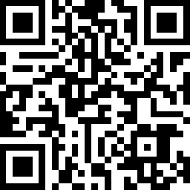

V 1.2

About this manual
This manual is intended for the AOBOET Uhome-NCA 6.8kWh Energy Storage battery, but the hybrid inverter and any other equipment is not included. The AOBOET hot line and http://ess.aoboet.com.au are both available if you want to get additional information.

Statement
Compliant to Best Practice Guide for Battery Storage Equipment—Electrical Safety Requirements- version 1- Pre-assembled integrated battery energy storage system equipment – Method 3 mandatory requirements and Optional requirements – a), c), e), f), g), h), i), j), k), l), m), n), o), p), q).
Contents
About this manual I
Statement II
1. Safety introduction - 1 -
1.1 Important Safety Instructions - 1 -
1.2 Warnings in this Document - 1 -
1.3 Battery handing guide - 1 -
1.4 Response to emergency situations - 2 -
1.5 Installers - 3 -
1.6 APP download - 3 -
1.7 Contact information - 3 -
2. Product Introduction - 4 -
2.1 Technical data - 4 -
2.2 Exploded views of battery - 4 -
2.3 Indicator and ports - 6 -
2.4 Communication interface plat - 7 -
2.5 How it works - 7 -
2.6 Feature - 8 -
3. Guidance for disconnection of batteries during shipment - 9 -
4. Installation Prerequisites - 10 -
4.1 Installation location - 10 -
4.2 Installation clearance - 10 -
4.3 Installation process - 11 -
4.4 Installation materials - 11 -
4.5 Tools - 12 -
4.6 Safety instruments - 12 -
4.7 Making network cable - 12 -
4.8 Storage - 12 -
5. Battery Installation - 14 -
5.1 Unpacking - 14 -
5.2 Package items - 15 -
5.3 Checks before installation - 15 -
5.4 Installation the battery - 17 -
5.5 Cable connections - 19 -
5.6 Parallel connection - 20 -
6. Configuration - 21 -
6.1 Configure device WIFI - 21 -
6.2 Register your account - 22 -
6.3 Setting for communication interface - 23 -
6.4 Settings for CAN /485 bus pins - 24 -
7. Commissioning - 26 -
7.1 Commissioning battery - 26 -
7.2 Shutting down battery - 26 -
8. Troubleshooting - 27 -
9. Firmware Update - 28 -

- Safety introduction
  - Important Safety Instructions
This manual contains important instructions for:
Uhome-NCA 6.8kWh/LV Energy Storage product
and this manual must be followed when installing and using this product.
The product is designed and tested in accordance with international safety requirements IEC 60364, but as with all electrical and electronic equipment, certain precautions must be observed when installing and/or operating the product. To reduce the risk of personal injury and ensure the safe installation and operation of the product, you must carefully read and follow all instructions, cautions and warnings in this manual.
  - Warnings in this Document
A warning describes a hazard to equipment or personnel. It calls attention to a procedure or practice, which, if not correctly performed or adhered to, could result in damage to or destruction of part or all of the AOBOET equipment and/or other equipment connected to the AOBOET equipment or personal injury.

Symbol | Description
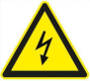 | Caution, risk of electric shock
 | Heavy enough may cause severe injure
 | Keep the battery away from open flame or ignition sources
 | Keep the battery away from children
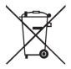 | Do not dispose of the product with household waste
 | Recycling
 | Read this manual before installation and operation

For safety reasons, installers are responsible for familiarizing themselves with the contents of this manual and all warnings before performing installation.
  - Battery handing guide
- Use the battery pack only as directed.
- If the battery defective, appears cracked, broken or otherwise damaged, or fails to operate, contract the AOBOET hot line immediately.
- Do not attempt to open, disassemble, repair, tamper with, or modify the battery. The battery pack is not user serviceable.
- To protect the battery and its components from damage when transporting, handle with care.
- Do not subject it to any strong force.
- Do not insert foreign objects into any part of the battery pack.
- Do not use cleaning solvents to clean the battery.
- The battery shall not be connected directly to SELV circuit.
- Maintenance
Cleaning the product. To clean this product, use a soft, dry cloth. If the surfaces are extremely dirty, use a soft cloth lightly moistened with a mild detergent solution. Do not use strong solvents such as alcohol, benzene, or thinner, as these might damage the surface of the product.
- Disposing the product. When the product reached to the end of its service life or defect beyond repair, dispose the product according to the disposal regulations for electronic waste in your area. Disposing the product must be carried out by qualifed personnel only. Contact authorized dealer or where you purchased.
  - Response to emergency situations
The AOBOET U-HOME battery is designed with multiple safety strategies to prevent hazards resulting from failures. However, AOBOET cannot guarantee their absolute safety for uncertain situations.
Anyway, the battery is not user-serviceable, if any accident happened, please contract with your distributor or AOBO after service hotline.
1.4.1 Leaking batteries
If the battery pack leaks electrolyte, avoid contact with the leaking liquid or gas. Electrolyte is corrosive and contact may cause skin irritation and chemical burns. If one is exposed to the leaked substance, do these actions:
Inhalation: Evacuate the contaminated area, and seek medical attention immediately.
Eyes contact: Rinse eyes with flowing water for 15 minutes, and seek medical attention immediately.
Skin contact: Wash the affected area thoroughly with soap and water, and seek medical attention immediately.
Ingestion: Induce vomiting as soon as possible, and seek medical attention immediately.
1.4.2 Fire
In case of a fire, make sure that an ABC or carbon dioxide extinguisher is nearby and does not use water to extinguish the fire.
WARNING
The battery pack may catch fire when heated above 150°C.
If a fire breaks out where the battery is installed, do these actions:
1. Extinguish the fire before the battery catches fire.
2. If the battery has caught fire, do not try to extinguish the fire. Evacuate people immediately.
WARNING
If the battery catches fire, it will produce poisonous gases. Do not approach.
1.4.3 Wet battery
If the battery is wet or submerged in water, do not try to access it. Contact AOBOET hot line or your distributor for technical assistance.
1.4.4 Damaged battery
If the battery damaged, please contract AOBOET hot line or your distributor for help as soon as possible, because damaged battery is dangerous and must be handled with extreme caution. Damaged battery is not suit for use and may pose a danger to people or property. If the battery seems to be damaged, return it to AOBOET or your distributor.
CAUTION
Damaged battery might export electrolyte or flammable gas, so contact AOBOET for advice and information immediately we will deal with it within 48h.
  - Installers
AOBOET Energy Storage battery is suggested installing by skilled worker or electrician. A skilled worker is defined as a people who had been trained and qualified electrician or had all of the following skills and experience:
- Knowledge of the functional principles and operation of on-grid Energy Storage systems.
- Knowledge of the dangers and risks associated with installing and using electrical devices and acceptable mitigation methods.
- Knowledge of the installation of electrical devices
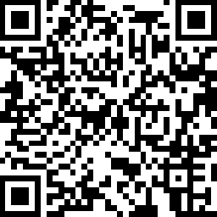
- Knowledge of and adherence to this manual and all safety precautions and best practices.
  - APP download
Aobo Energy storage battery monitor App could be downloaded by http://ess.aoboet.com.cn/index.php?s=/Home/Index/download.html or scanning this bar code with your smart phone.
  - Contact information
Use the contacts below for technical assistance. This phone numbers is available only during business hours on weekdays.

China |  | Australia
Phone number | 86-510-85366880 | Phone number | +61 03 9645 8001
Address | No.358 Qianlu Qianqiao Huishan District, Wuxi, Jiangsu, P.R. China | Address | UNIT 211, 370 St Kilda Rd, Melbourne VIC 3004.

E-mail: info@aoboet.com.au

- Product Introduction
  - Technical data
Model | Uhome-NCA 6.8kWh/LV
Total Energy* | 6.8kWh
Usable Energy(DC)* | 6.0kWh
Nominal Charge/Discharge power | 3kW
Peak Power(Only discharge) | 7kW for 3 seconds
Peak Current(Only discharge) | 135A for 3 seconds
Voltage | 43-57.5V DC
Nominal Voltage | 50.4V DC
Nominal Current | 60A
Short circuit current | 3130Apeak at 6ms，2480Arms
Max. Charge voltage | 58.8V
Recommended peukert setting(Off-grid) | 1.05
Max. recommended DOD (Off-grid) | 90%
Operating Condition | Indoor or outdoor
Operating Temperature | From -10~45℃
Dimension(L*W*H) | 525*675*238 mm
Weight | 62kg
Cooling Type | Natural cooling
Case Material | Metal + Plastic
Color | Black + Silver grey or white
Installation | Free standing
IP rating | IP 65
Protective Class | I
Max. number of parallel connection | 4
Warranty | 10 years(Daily cycle)
Life Span | >15 years
Communication | CAN/ RS485
Protection Mode | Triple hardware protection
Battery Protection | Over-current/Over-voltage/Short circuit/ Under-voltage/Over temperature
Safety | Cell UL 1642
Battery Pack TUV
(IEC 62619, IEC 62040-1)
Hazardous material classification | 9
Transportation | UN 38.3
Testing conditions based on temperature 25℃ at the beginning of life.
*Total Energy/Usable Energy measured under specific conditions from AOBOET 0.2C CC-CV
  - Exploded views of battery
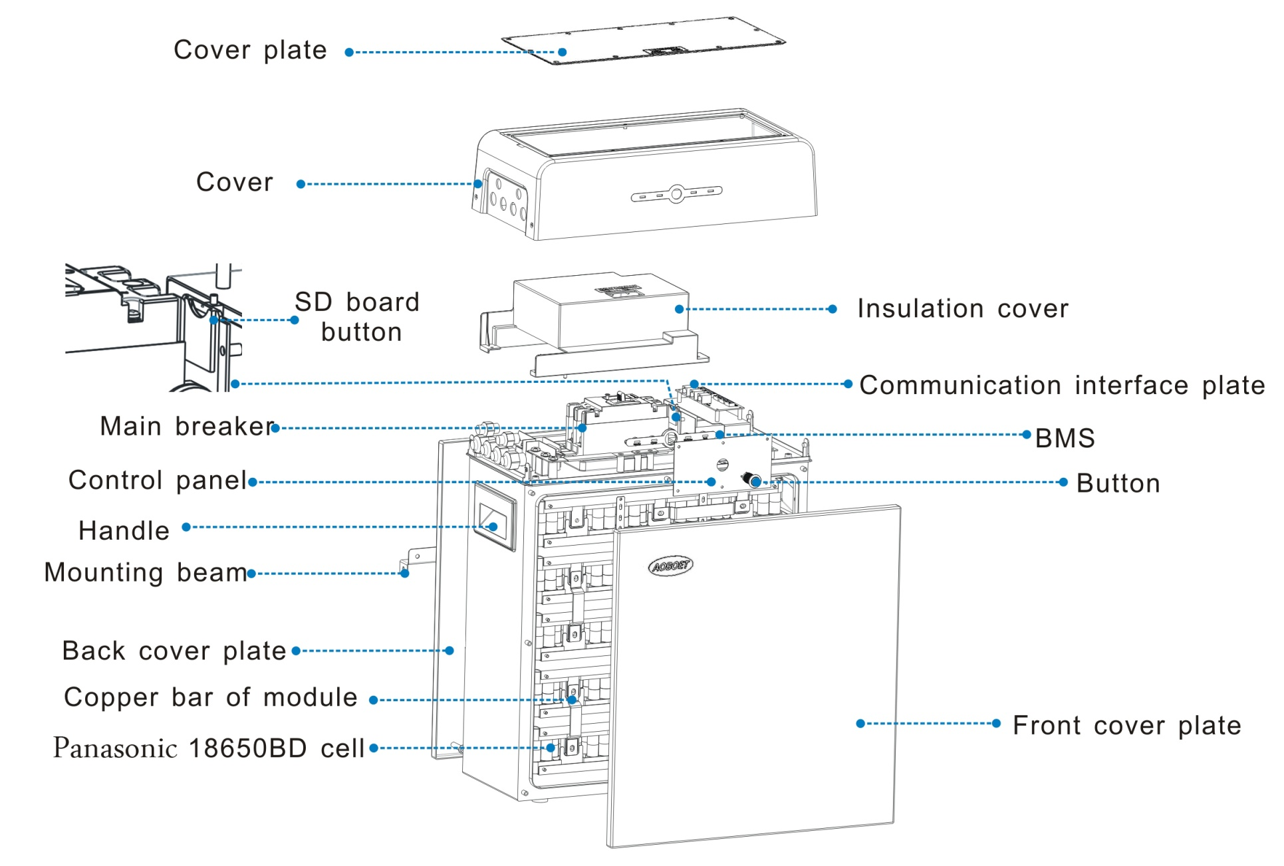
  - Indicator and ports
    - Indicator
There are four LED indicators on the front of the battery to show its operating status.
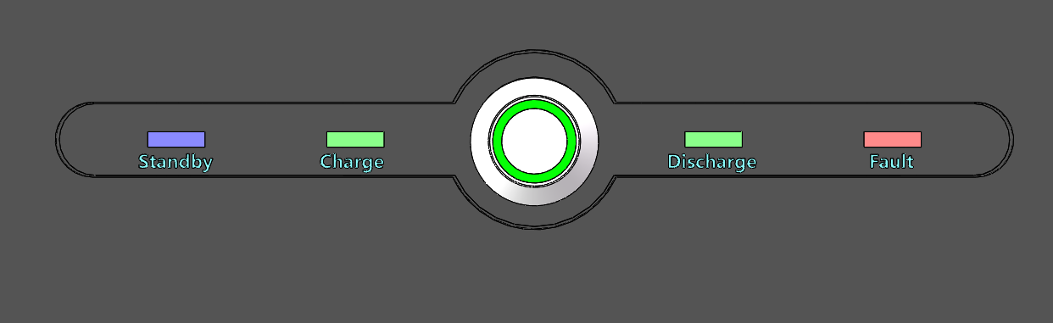
Table 2-1 Designations on the battery
Item | Designation | Definition
1 | Standby | Battery no power output or input
2 | Charge | Battery is charging
3 | Discharge | Battery is discharging
4 | Fault | Battery is in a warning state, see troubleshooting in Chapter 6
    - Ports
The power cable connectors and communication cable
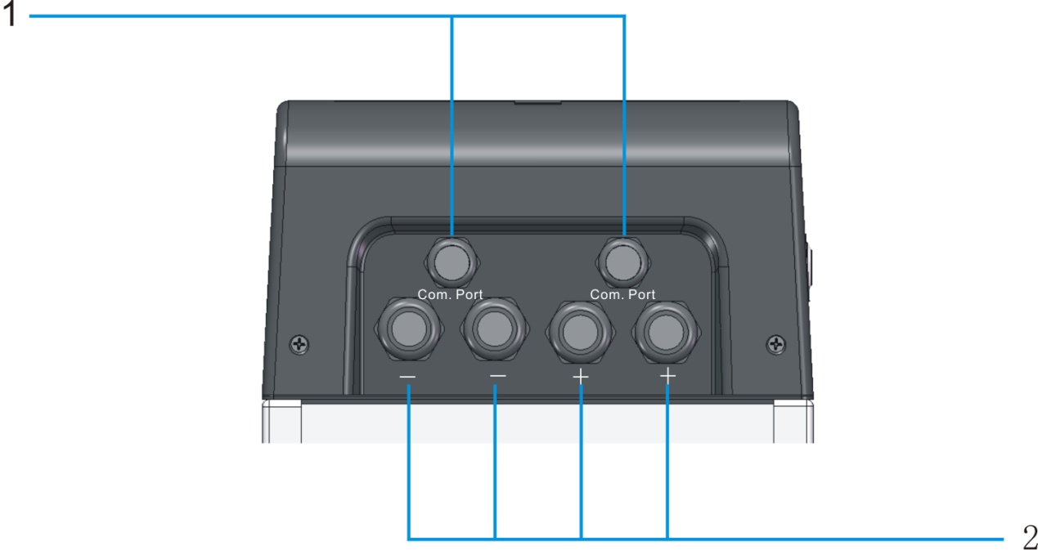

1- Data cable interface
2- Power cable interface
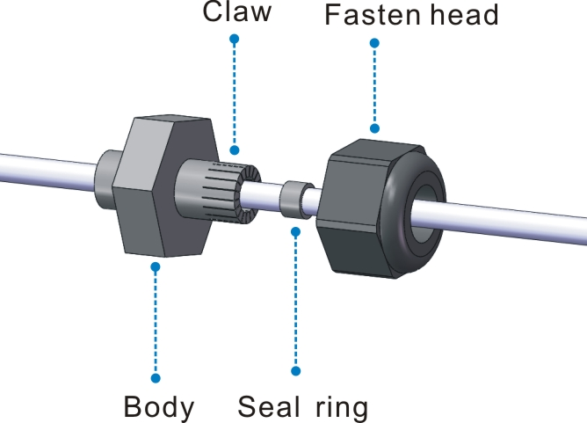
Building up illustration of waterproof terminal
  - Communication interface plat
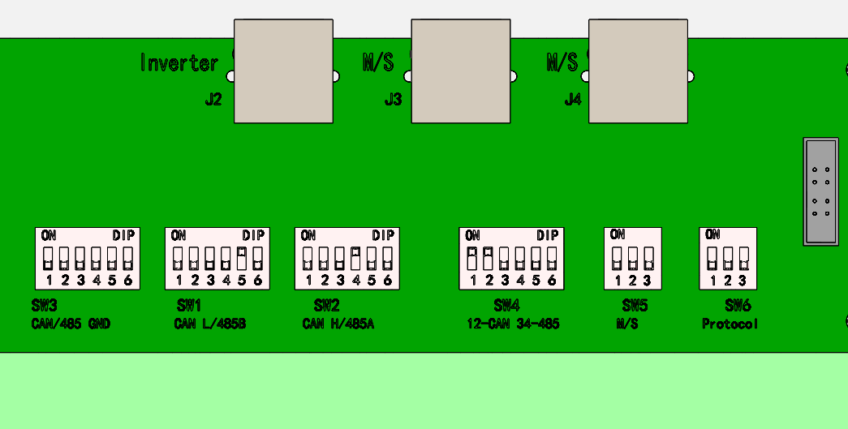
J2 | Communication interface for battery or master battery with Inverter
J3&J4 | Communication interfaces for batteries between parallel connected batteries
SW1&SW2&SW3 | DIP switches for CAN and RS485, see part 5.3
SW4 | DIP switch select for CAN or RS485
SW5 | DIP switch select for master and slave battery, see part 5.2
SW6 | DIP switch to select default protocol type, 000₂ is the default configuration

  - How it works
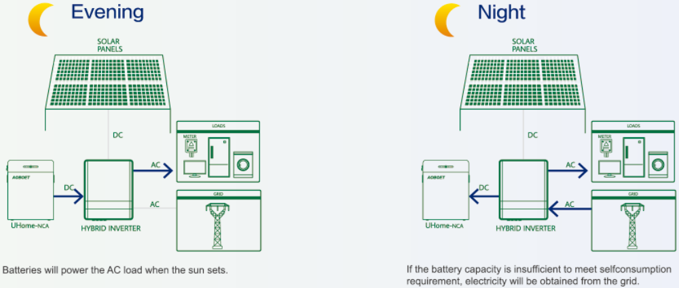
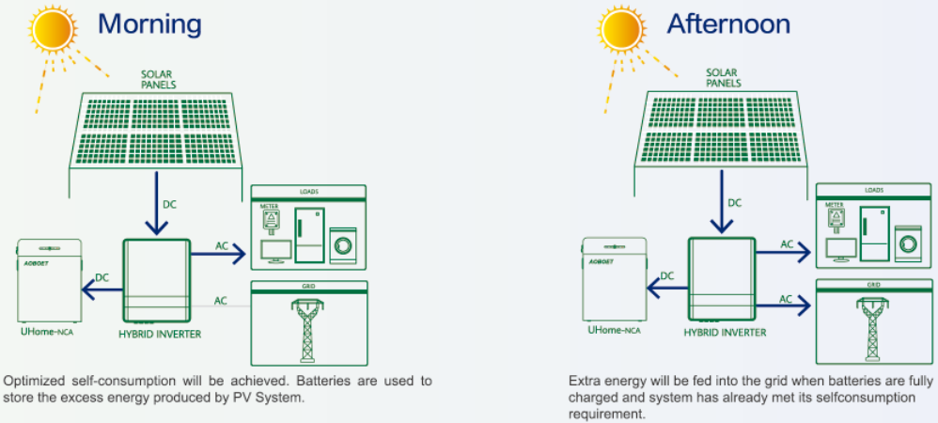

  - Feature
The AOBOET Uhome Energy Storage battery has following features:
- Energy storage unit: This battery is suit for photovoltaic system compatibility.
- Battery management system (BMS): The battery built-in BMS monitors its operation and prevents the battery from operating outside design limitations. See Troubleshooting on Chapter 8.
- Monitor: The battery BMS built-in with WIFI module, the battery running information could be seeing in mobile phone and computer.
- Easy firmware update: The BMS firmware can be updated to the latest version. See Chapter 9 Firmware Update on page 28.
- Expandability: The battery capacity can be increased by adding another battery. See part 5.6 Parallel connection on page 20.

- Guidance for disconnection of batteries during shipment
  - AOBOET Uhome-NCA 6.8kWh/LV is not suit for air transport.
  - Cartons that have been crushed, punctured, or torn in such a way that contents are revealed shall be set aside in an isolated area and inspected by a skilled person. If the package is deemed to be not shippable, the contents shall be promptly collected, segregated, and either the consignor or consignee contacted.
  - The DC circuit of AOBOET Uhome-NCA 6.8kWh/LV battery has been disconnected before outgoing. The DC breaker recommended to be re-connected by skilled installer before use.
  - A precautionary label had be affixed to the shipping carton to alert individuals as to the battery within the package have been disconnected, otherwise, the battery should not be transported.
  - We have conducted comprehensive tests to ensure the equipment they distribute around the world is safe for shipping transport. These products shall be handled with care and immediately inspected if visibly damaged. If the cartoon visibly damaged, please contract with AOBOET hot line to confirm whether the battery could be use safely or not.
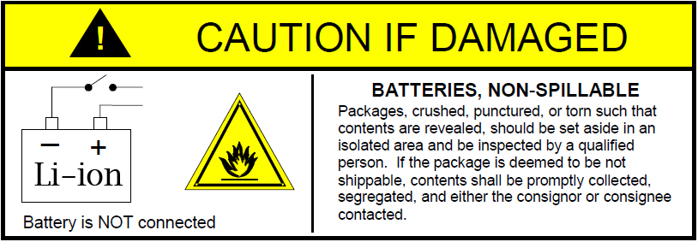

- Installation Prerequisites
  - Installation location
Make sure that the installation location meets the following conditions:
- The building is designed to withstand earthquakes.
- Far away from the sea to avoid salt water and humidity.
- The floor is flat and level.
- No flammable or explosive materials nearby.
- Optimal ambient temperature is between 15℃ and 30°C.
- Temperature and humidity stays at a constant level.
- Minimal dust and dirt in the area.
- No corrosive gases present, including ammonia and acid vapor.
- Do not block any ventilation openings. The openings shall never be blocked by placing any object on this product.
- Do not install this product in a place with heat source, protect it from over heating.
The AOBOET Uhome battery is rated at IP65, so the battery could be installed outdoors as well as indoors. But if installed outdoors, do not allow the battery to be exposed to direct sunlight or moisture.
If the ambient temperature is outside the operating range, battery will protect itself by shutting down. The battery optimal operate temperature is 15°C to 30°C. Frequent exposure to severe operating condition would exacerbate the performance and lifetime of the battery.
  - Installation clearance

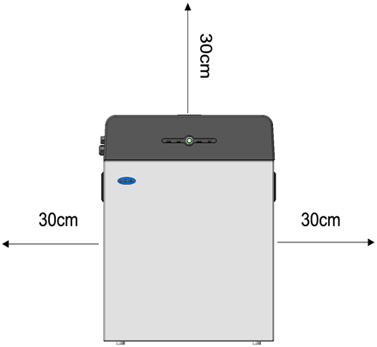
This product must be installed with clearance at the left, right, top, bottom and front of the product larger than 300mm. Only the battery can be installed at the bottom
clearance space of the product.
  - Installation process
The battery should be installed according to the following flow chart. The detail installation process described in chapter 4 Install process.
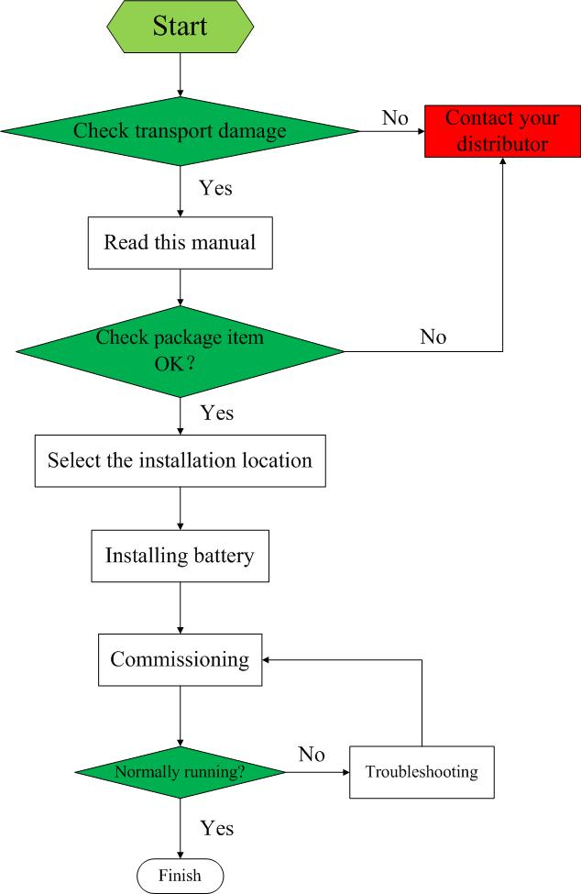
  - Installation materials
Following installation materials should be prepared by installers.
- Power cable
- Data cable
- Ground wire
- RJ45 plug
NOTICE
Make sure that the cross-sectional area of charging cables is 25 to 35 mm².
NOTICE
A Bi-pole DC circuit breaker have been mounted inside the battery system enclosure. A breaker between aoboet battery and inverter was recommended to install, and the breaker’s min. current should be over 150A or following with local regulations.

  - Tools
To install the battery pack, those following tools are required:
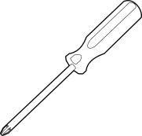
Phillips screwdriver | Torque wrench | Cable crimper | Wire clamp
Voltmeter | Tape measure | Drill | Flat-head screwdriver
In order to protect operator and installer’s safety, please select and use suitable tools and measuring instruments that are certified for precision and accuracy.
  - Safety instruments
When dealing with the battery, following safety gears should be equipped. Installers must meet the relevant requirements of IEC 60364 or the domestic legislation and other relevant international standards.
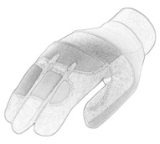
Insulated glove | Safety goggles | Safety shoes
  - Making network cable
The network cable between AOBOET battery and inverter should be made like that diagram. If available, use a LAN cable tester to see whether the cable is faulty.
  - Storage
If the battery is not to be installed immediately, or removed from operation and needs to be stored for a long period, please choose an appropriate location to store it. Instructions for storage are:
- Do not stack more than four battery boxes.
- The temperature of battery stored recommended in the range of -20°C to 50°C.
- The humidity should be less than 95 % RH.
- Do not expose to water
The battery box should be upright as shown in the following figure and not stacked upside down when storing the battery box.
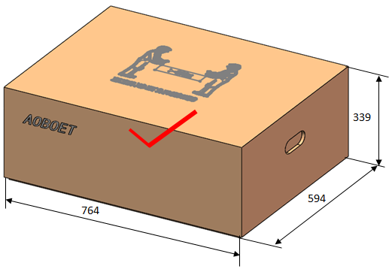
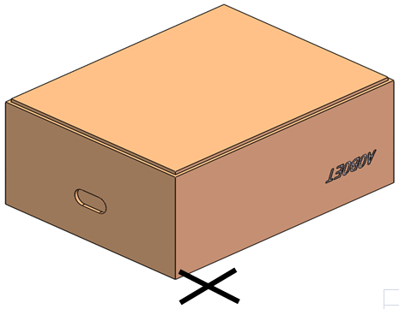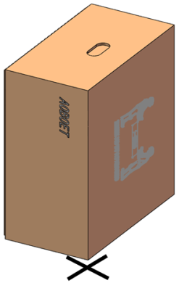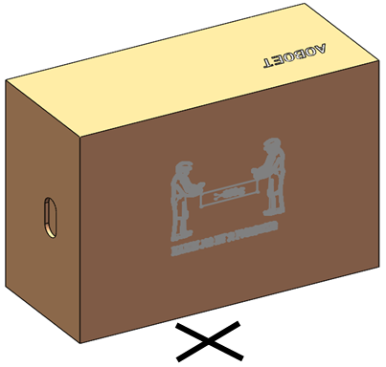
If the battery needs to be stored over 3 months, the main breaker of battery suggests be disconnecting. Otherwise, the battery would discharge at a minimum rate and capacity degrades depended on storage time, the battery self-consumption less than 5w. And, if the battery stored over 6 months, it is suggested to connect the battery with inverter and commission the system.

- Battery Installation
  - Unpacking
- WARNING
The battery is 62kg and it is too heavy for one to carry. Make sure that two or more persons are available.

- Cut the packing belt and remove the packing box top cover.
- Remove the bracket.
- Take out the battery with hand hole in cardboard.
- Pull out the battery pack and stand it upright. Check if the battery pack is damaged.

  - Package items
These items are included in the package.
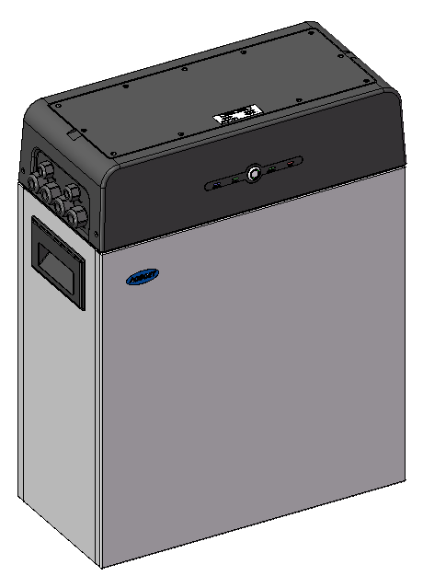 | 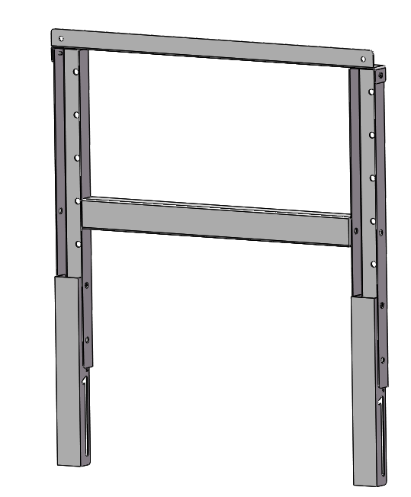 | 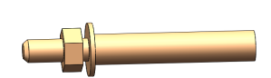
Battery | Bracket | Screw anchors M6*4
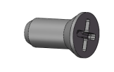 | 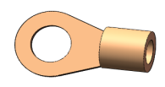 | 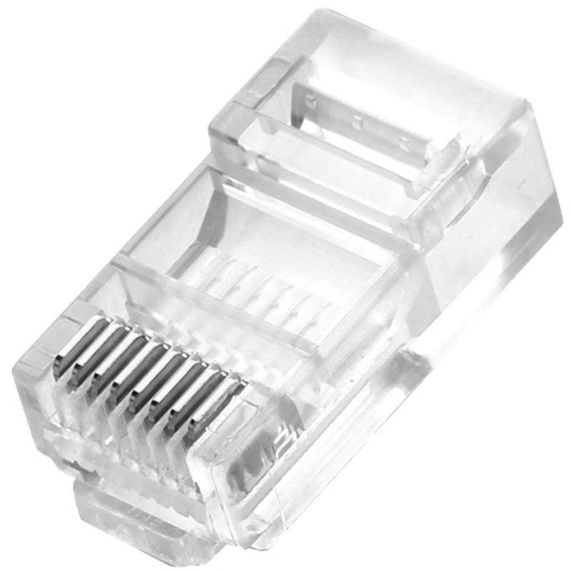
Screws M5*2 | Cable lug 25-8*4 | RJ45 plug*2

  - Checks before installation
There are a few things to check before installing the battery to ensure that it has no defects.
Check item 1: Check the main breaker safety and stability;
Check item 2: Check the battery voltage.
WARNING
If this checking process is executed for any reason after the battery is fully installed, make sure that the inverter is turned off or break the connection between battery and inverter while checking the battery.
CAUTION
There is a hook on the cover plate back, please following the indication which stuck on the cover.
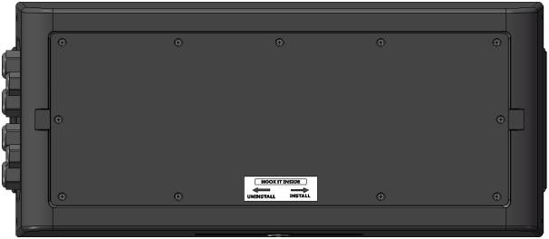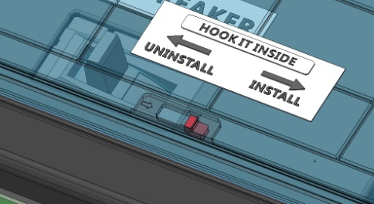
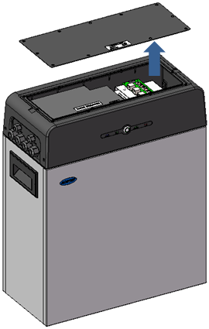 | - Remove the top cover. Loosen the eight hex socket screws at the cover, and pull it up.  - Make sure to set the SW5 select DIP switch to 001₂. See part 5.2.
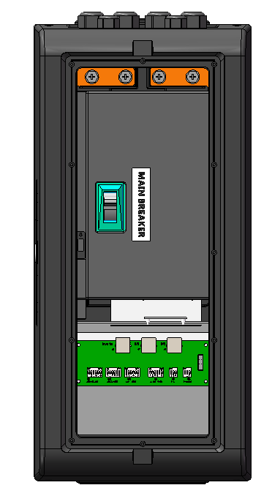 | - At the first installation, make sure that the main breaker is in the OFF position.  - Make sure the main breaker behind the OFF position until it cannot go any further and then push it to the ON position. If the breaker moves to any other positions by itself, do not use the battery. Contact AOBOET hot line or your distributor.
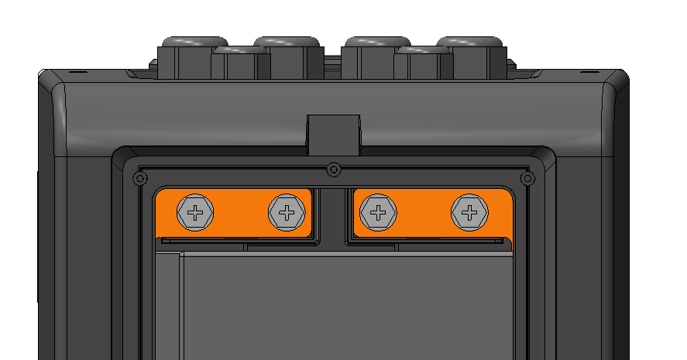 | - Press and hold the panel button for about 4 seconds and then release it after the four LED lights on, measure the voltage at the terminal block with a voltmeter. If the voltage is lower than 43 V, do not use the battery and contact AOBOET hot line or your distributor.  - Switch the main breaker OFF, and then measure the voltage at the terminal block with a voltmeter again. If the voltage is higher than 0V, do not use the battery and contact AOBOET hot line or your distributor.
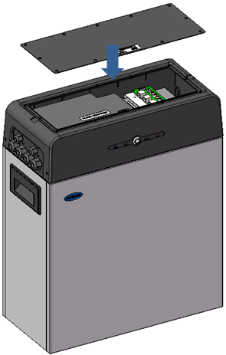 | - Replace the top cover and tighten the screws to a torque of 0.25 N·m.
  - Installation the battery
To prevent the battery from moving, make sure the battery fixed to a wall.
Note
The symbol located on the back cover plate, and the earth wire between battery and inverter is not compulsive but recommended.
Note
If the battery is installed above the floor or on a platform, make sure that the wall or platform is capable of supporting the battery’s weight.
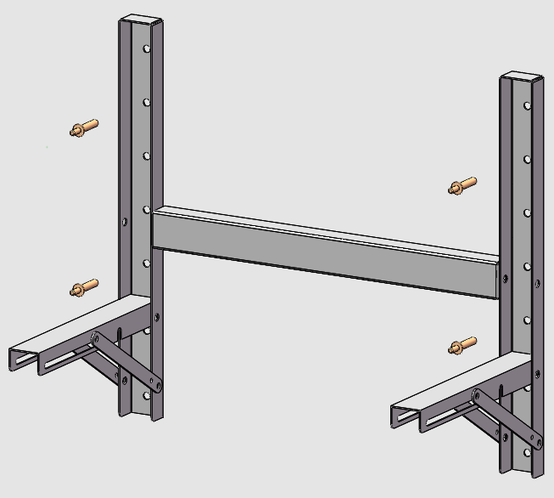 | - Determine bracket mounting place to be fixed using the bracket.  - Drill holes in the wall for the M6 (0.25 in) screw anchors, and the hole depth should be at least 50 mm.
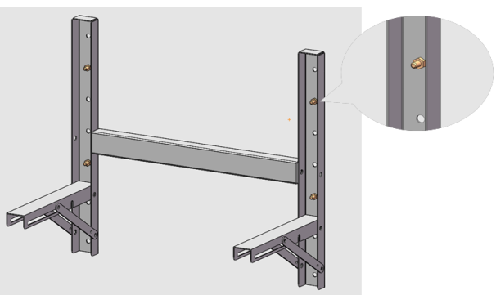 | - Drive the screw anchors through the mounting bracket into the holes.  - Tighten the screws to a torque of 2.5 N·m.
 | - Fasten the mounting beam to battery.
 | - Fixing the battery to bracket with screws.
  - Cable connections
Warning
Before connecting battery with inverter, please make sure that no inverter connected or the inverter turned off.
    - Connect the data cable
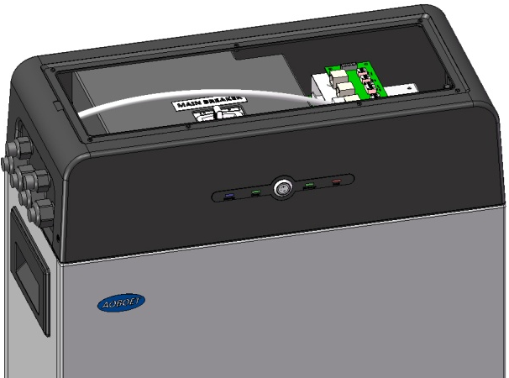 | Feed a data cable through the large grommets and then through the data cable entries make sure the SW4 DIP switch select 001₂.
    - Connecting the power cables for battery
Feed a pair of power cables through each of the large grommets and then through each of the large cable entries.
CAUTION:
Pay attention not to reverse polarity. Connection with reversed polarity will cause severe damage to the battery and even fire.
  - Parallel connection
    - Data cable connect between batteries
Feed a data cable through the large grommets and then through the data cable entries, the DIP switch select reference part 5.2
    - Power cables connect between batteries
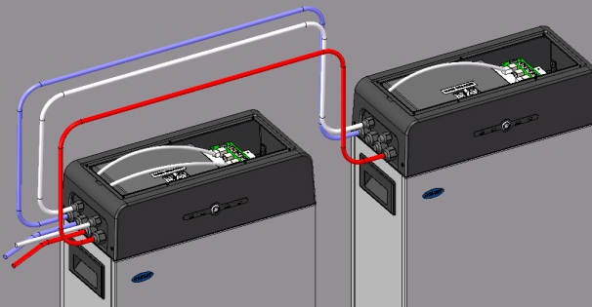 | Feed another pair of power cables through master and slave battery’s large grommets and then through each of the large cable entries.
Caution
Uhome-NCA 6.8kWh/LV energy storage battery only could be used by parallel mode if two or more batteries installed.
Note:
Before two or more batteries installed in parallel, please check the voltage of each battery and make sure the voltage different less than 1.0V.
- Configuration
DIP switch should be set correctly for proper communication between inverter and battery
If parallel connecting multiple batteries, please set the DIP switches as following:
  - Configure device WIFI
The AOBOET Uhome battery has a built-in WIFI module for use with the aoboet APP.
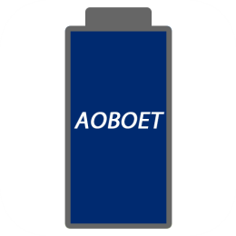
- Remove the cover by pulling it up to expose the SD card board. The WIFI setting of battery should be as following
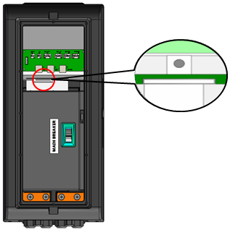
- Press and hold the white button for 7 seconds on SD card board.
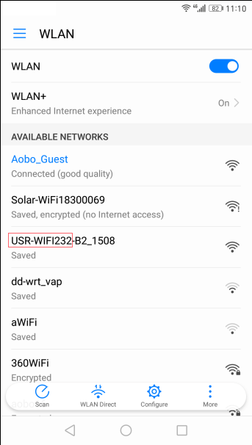
- Connect the ‘USR-WIFI232-XX_XXXX’ with your smart phone, and then the light of WIFI will turn on by itself within 5 seconds.
- Open the APP monitor of battery, select ‘Config Device Wifi’ option box.
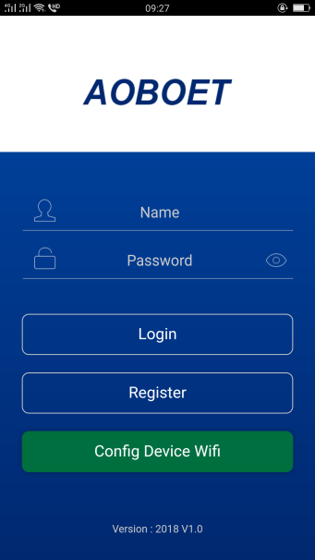
- Search and select SSID connected and input the password, press ok and finish. The light of WIFI module would light automatically under WLAN accessible condition.
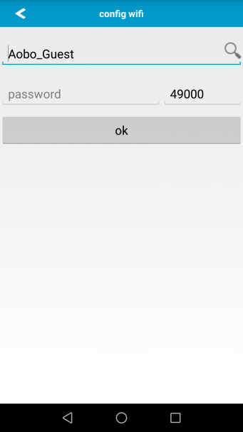
Note
If the WIFI cannot be set or there is no WLAN accessible, the battery can still operate normally.
  - Register your account
Note
The AOBOET Uhome battery could be registered only one time.
- Open the APP monitor of battery, select ‘Register’ option box.
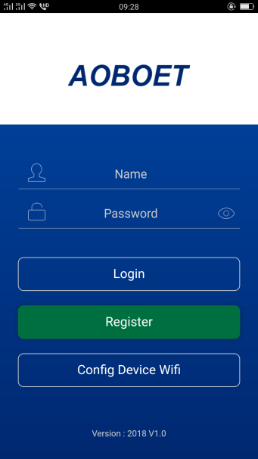
- After scanning the bar code of battery, there are some personal messages need to be filled which noted by “*” symbol.
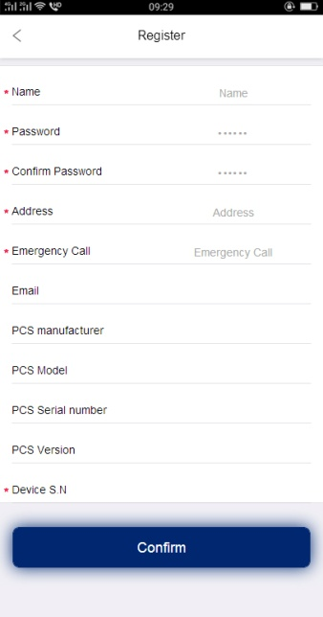
- After those messages filled, the APP would jump to the running interface automatically.
Note
The AOBOET Uhome battery running is not associated with registration or not.
  - Setting for communication interface
For Uhome-NCA 6.8kWh Energy Storage battery, the limit of parallel number is 4. For each connecting mode, the DIP switch SW5 dial mode like following tables 5-2.
Table 5-2 The DIP switch SW5 selected for 1 battery connected with inverter
Parallel battery | Group | DIP Switch
1 | — | 000₂ or 001₂
The DIP switch SW5 selected for 2 batteries connected with inverter
Parallel batteries | Group | DIP Switch
2 | Master | 011₂
 | Slave | 010₂
The DIP switch SW5 selected for 3 batteries connected with inverter
Parallel batteries | Group | DIP Switch
3 | Master | 101₂
 | Slave 1 | 010₂
 | Slave 2 | 100₂
The DIP switch SW5 selected for 4 batteries connected with inverter
Parallel batteries | Group | DIP Switch
4 | Master | 111₂
 | Slave 1 | 010₂
 | Slave 2 | 100₂
 | Slave 3 | 110₂
Note
If two or more batteries connected with parallel mode, batteries need to be restarted.
  - Settings for CAN /485 bus pins
Confirm that the CANL/485B DIP switch is set to SW2 which pin is used for CAN high signal by inverter (4-CANH/485A), and the CANL/485B DIP switch is set to SW1 which pin is used for CAN low signal by inverter (5-CANL/485B).
As SW3 the CAN/485 GND DIP switch, installer should confirm which pin is used for ground by inverter or not.
Note
The battery default protocol is CAN bus, if a inverter communication mode is RS485 or other protocol, please contact aoboet hot line before installed the battery.
- Commissioning
  - Commissioning battery
If there is only one battery installed, use the following steps to put it in operation:
- Open the top cover. Be careful of live connections.
- Move the main breaker to the ON position.
- Press and hold the panel button on the side of the unit for about 4s, after the four indicator lights on, release the panel button.
- Make sure that the Standby light is on. If it stays off, do not use the battery and contact AOBOET or your distributor.
- Turn the inverter on, and wait for the start-up sequence to complete fully.

When there are two or more batteries connected with parallel mode, after the charging cable and the data cable has been connected correctly, follow these steps to put them in operation:

- Check battery voltage level is above 43V
  - If battery voltage is under 43V contact your distributor or AOBET after service hot line for help.
- Move the main breaker to the ON position. Press and HOLD the panel button for about 4s, after four seconds the indicator lights will turn on.
- Release the panel button.
  - For all batteries, make sure that the Standby light is on.
  - Make sure the maximum voltage different between batteries less than 1.0V.
  - If not, the installer should balance the battery voltage and then parallel connect batteries together.
  - Set the DIP switches like part 5.2 Setting for communication interface.
- Turn the inverter on, and wait for the start-up sequence to complete fully.

  - Shutting down battery
Shut down the battery only when the battery is no charge or discharge current which could be seen in your smart phone with APP.
- Remove the top cover from the battery. Be careful of live circuits.
- Turn off the battery by moving the circuit breaker switch to the OFF position.
- Make sure that every light on the battery is off.
- Replace the top cover.
- Troubleshooting
- Every fault is presented by a fault code. If the battery fault light is on, please check the Fault code in Homepage.
- If the battery fault light on, pls check the Troubleshooting number in Homepage in your aoboet APP, if the code is 0x1***, this problem would be recovered by itself. But if the code is 0x2*** or 0x3***, please contact the AOBOET after service hot line or your distributor for help.
- If the information of battery cannot be seen in the monitoring system, check the battery status first. If the battery status is OFF, please turn the battery on, and then check the WLAN is accessible for battery.
- If Register the battery failure, please check the network of mobile phone nearby the battery installation site available and stable.

Table 7-1 Fault Code of Battery
Fault Code | Detail fault message
0x1001 | Battery under voltage warning
0x1002 | Battery over voltage warning
0x1003 | Battery under temperature warning
0x1004 | Battery over temperature warning
0x1005 | Battery charge over current warning
0x1006 | Battery discharge over current warning
0x1007 | Cell over discharge warning
0x1008 | Cell over charge warning
0x1009 | Battery charge with over temperature warning
0x1010 | Battery discharge with over temperature warning
0x1011 | Battery charge with under temperature warning
0x1012 | Battery discharge with under temperature warning
0x2001 | Battery under voltage protect
0x2002 | Battery and cell over discharge protect
0x2003 | Battery over charge protect
0x2004 | Battery over voltage and cell over charge protect
0x2005 | Battery under temperature protect
0x2006 | Battery over temperature protect
0x2007 | Battery charge over current protect
0x2008 | Battery discharge over current protect
0x2009 | Cell over discharge protect
0x2010 | Cell over charge protect
0x3000 | Communication broken between master and slave Battery

- Firmware Update
It is possible to update the BMS firmware version manually via using a SD Memory card or via the WIFI monitor system App.
After a new firmware version is upload to the server, the firmware could be updated over the Internet by itself after holder confirmed.
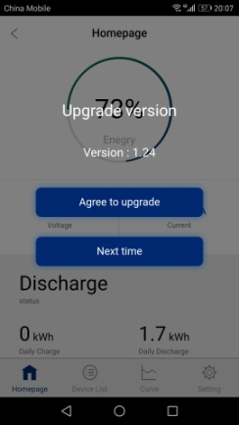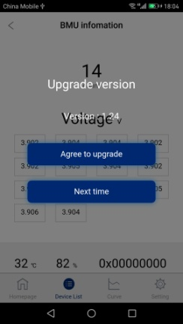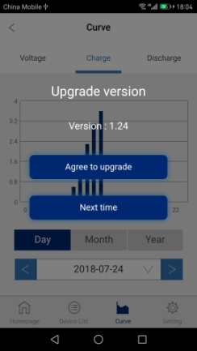
If the internet is not accessible, firmware could be updated with memory card. The operation progress as following:
- Inside the memory card to the card slot.
- Press and hold the SD card slot button for 3s and release it, then the firmware would update automatically.
- The capacity of the memory card must not be greater than 1 GB.
- The memory card must be formatted in FAT16 or FAT32.
- It must have only one firmware file in the root directory.

